<https://www.mathworks.com/help/wavelet/ref/ref_0233x.gif>

Figure 1: Wavelet Features of Voice of Addict’s using DB2 at level 2



Figure 2: Wavelet Features of Voice of Addict’s using Haar at level 2



Figure 3: Wavelet Features of Voice of Addict’s using Sym2 at level 2



Figure 4 : Wavelet Features of Voice of Normal Person using DB2 at level 2



Figure 5 : Wavelet Features of Voice of Normal Person using Haar at level 2



Figure 6: Wavelet Features of Voice of Normal Person using Sym2 at level 2

If we measure the power spectrum of the wavelet decomposition vectors of the voices of people addicted to different frequencies, we see that the amount of power varies at different frequencies in the case of addicts. The change in power relative to the frequency is much greater and the number of times the change in power we see from the figure. In the case of the wavelet cards of ordinary people's voices we see that they basically change according to a certain and the power change relative to the frequency is the same for all signals.



Figure 7: dsp





Figure 8dsp



When we translate the voice of an alcoholic into a wavelet function and portray it as a power spectrum, we find that those who are addicted to alcohol or cigarettes do not have a consistency between the maximum points of the wavelet coefficient in their voices. The width of the wave is relatively small at the point where the highest points of the coefficient are found.

For those who are not addicted to alcohol or cigarettes, we find that the maximum points of the wavelet coefficient of the voice are much wider and the maximum point density is much higher than the wavelength coefficient of the voice of the addicted person.





Analyzing the voices of addicts, we find that they usually use different frequencies when speaking and use a greater number of frequencies. Where by analyzing the voice of a normal human being we see that a certain number of people use certain frequencies and use a small number of frequencies.

And in the case of the voice signals of the addicts, the frequency they use and the frequency range is much less than that of the normal human voice.

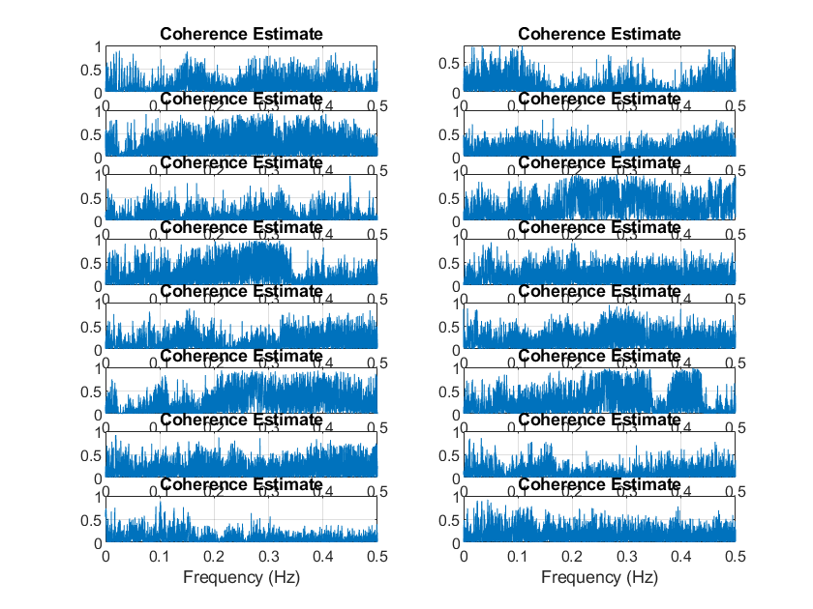

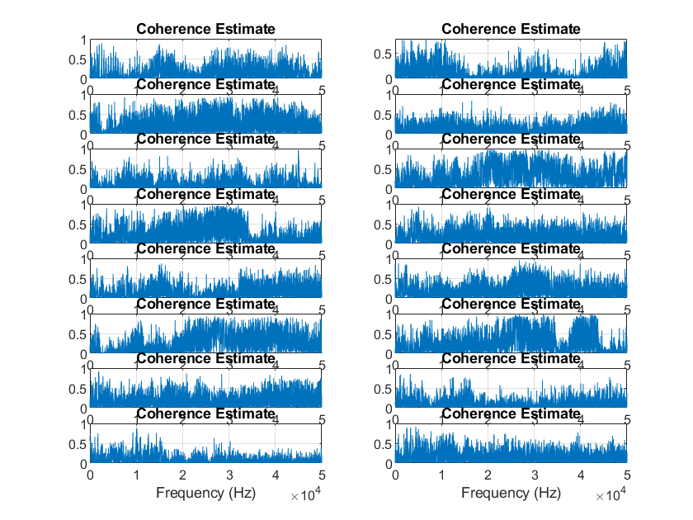

From the above two figures we can conclude that the very small frequencies indicate the difference between the two types of signals. The signals at higher frequencies are homogeneous and the two types of signals at higher frequencies are almost identical.